Training Model:

We went with the approach of separate models for Classification and Regression. We tried multiple models like ResNet, Mobilenet, Densenet and are mentioning the finding of the top models according to accuracy on test set.

Classification Modelling:

Problems faced:

* Training and test data size was quite big and with collab, the training of models took a lot of time.

Steps for model training:

* We tried bringing the number of features down (PCA), but the accuracy was less using that (<80), so eventually we did not go ahead with PCA for this use case.
* We used transformations on the train set. We used the FastAI transformation library (<https://fastai1.fast.ai/vision.transform.html>) which is based on the following paper.

https://arxiv.org/abs/1312.5402 - “The techniques include adding more image transformations to training data, adding more transformations to generate additional predictions at test time and using complementary models applied to higher resolution images.“

Each data has: 50% to perform

* Horizontal Flip

75% to perform

* Rotation of maximum ±10 degrees
* Zoom between 100% - 110% (equally probable)
* Symmetric Warp 0.2 Magnitude in any direction
* Brightness Change of ±20%
* Contrast Change of ±20%
* We followed the following strategies to train and fine tune our model,
  + Mixup Strategy – Initially we used mixup to remove the memorization and sensitivity problems and once the model was at a decent accuracy, we again trained the model without mixup. This helped us achieve close to 90% Top1 accuracy and above 97% top 5 accuracy, in relatively lesser epochs, which was needed since we were short on training resources (GPU).

“Large deep neural networks are powerful, but exhibit undesirable behaviors such as memorization and sensitivity to adversarial examples. In this work, we propose mixup, a simple learning principle to alleviate these issues. In essence, mixup trains a neural network on convex combinations of pairs of examples and their labels. By doing so, mixup regularizes the neural network to favor simple linear behavior in-between training examples.” – Ref : https://arxiv.org/abs/1710.09412

* + Unfreeze all the layers of the model and training using the learning rate slice argument also experimenting with the weight decay, batch size.
    - Retraining the whole Neural network instead of last layer. max_lr takes a slice argument. That is telling the model to linearly decrease learning rates as the models goes deeper.
    - Earlier layers will have a smaller learning rate, latter one will have higher. This is due to the fact that as the models goes deeper, each layer learns to capture features that is more specific to the problem domain. We want the early layers to update less as they capture more general features such as edge and corners, which are usually general to many vision problems.
  + Using 1 cycle - Author recommends to do one cycle of learning rate of 2 steps of equal length. We choose maximum learning rate using range test. We use lower learning rate as 1/5th or 1/10th of maximum learning rate. We go from lower learning rate to higher learning rate in step 1 and back to lower learning rate in step 2. We pick this cycle length slightly lesser than total number of epochs to be trained. And in last remaining iterations, we annihilate learning rate way below lower learning rate value(1/10 th or 1/100 th).

The motivation behind this is that, during the middle of learning when learning rate is higher, the learning rate works as regularisation method and keep network from overfitting. This helps the network to avoid steep areas of loss and land better flatter minima. – Ref - https://arxiv.org/pdf/1506.01186.pdf

Training and Testing results:

Resnet152:

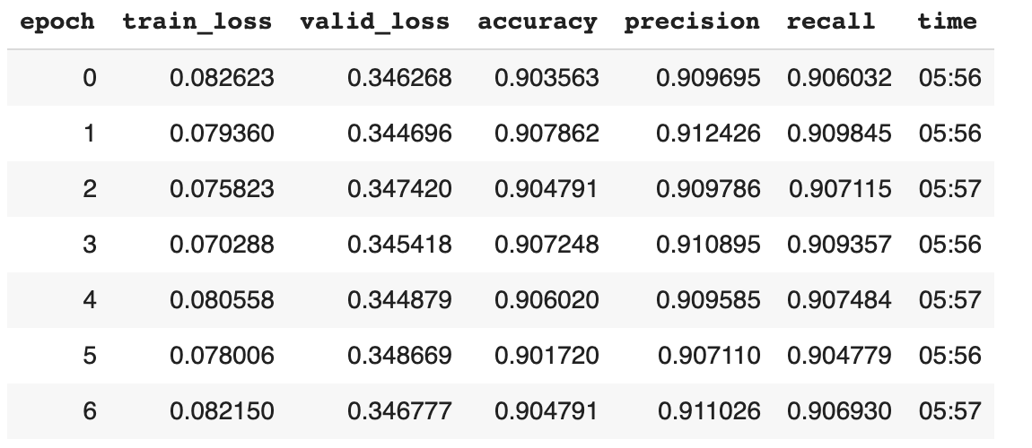

On Test set:

# loss, accuracy

[0.3675094, tensor(0.9038)]

Top 1 accuracy – 90.34%

Top 5 accuracy – 97.69%

The model got confused between similar looking cars.

Top 5 most confused:

[('Audi S5 Coupe 2012', 'Audi A5 Coupe 2012', 17),

('Audi TTS Coupe 2012', 'Audi TT Hatchback 2011', 16),

('Dodge Caliber Wagon 2012', 'Dodge Caliber Wagon 2007', 14),

('Audi TT Hatchback 2011', 'Audi TTS Coupe 2012', 12),

('BMW 6 Series Convertible 2007', 'BMW M6 Convertible 2010', 12),

Densenet 201

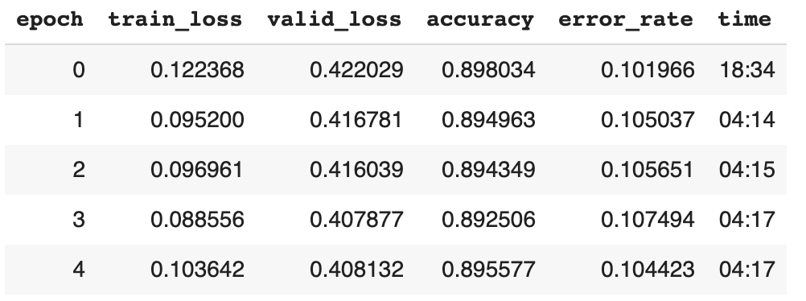

# loss, accuracy,

[0.4211438, tensor(0.8939)]

Top 1 accuracy – 89.39%

Top 5 accuracy – 96.8%

The model got confused between similar looking cars.

Top 5 most confused:

[('Audi S5 Coupe 2012', 'Audi A5 Coupe 2012', 16),

('Dodge Caliber Wagon 2012', 'Dodge Caliber Wagon 2007', 14),

('Audi TTS Coupe 2012', 'Audi TT Hatchback 2011', 13),

('Chevrolet Express Cargo Van 2007', 'GMC Savana Van 2012', 13),

('Chevrolet Silverado 1500 Hybrid Crew Cab 2012',

'Chevrolet Silverado 1500 Extended Cab 2012',

13)

**Densenet121:**

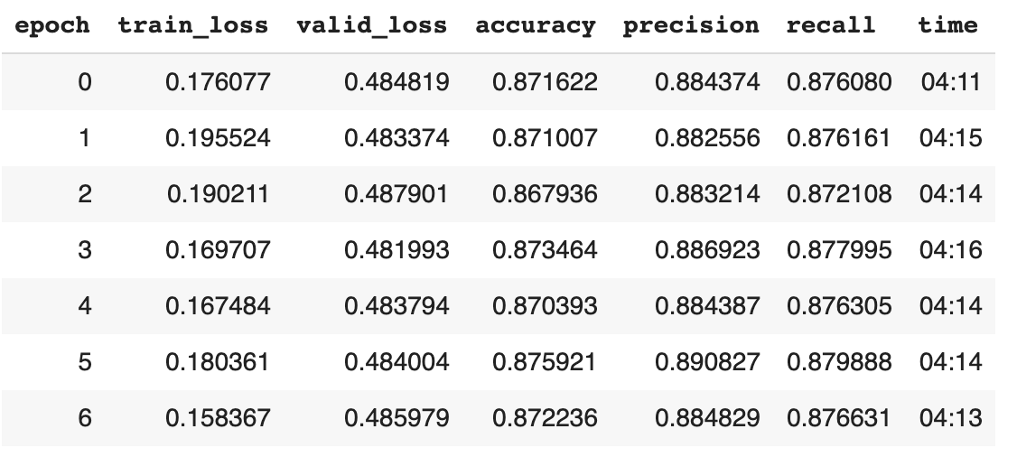

# loss, accuracy

[0.5020263, tensor(0.8734)

Top 1 accuracy – 87.33%

Top 5 accuracy – 96.19%

Most confused:

[('Audi S5 Coupe 2012', 'Audi A5 Coupe 2012', 22),

('Audi TTS Coupe 2012', 'Audi TT Hatchback 2011', 16),

('Dodge Caliber Wagon 2012', 'Dodge Caliber Wagon 2007', 13),

('BMW 6 Series Convertible 2007', 'BMW M6 Convertible 2010', 12),

('Chevrolet Express Van 2007', 'GMC Savana Van 2012', 12),

**Mobilenet:**

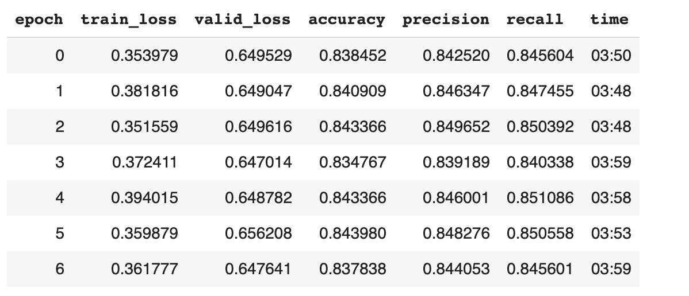

loss, accuracy

[0.6534206, tensor(0.8365)]

Top 1 accuracy – 83.6%

Top 5 accuracy – 94.08%

Most confused:

[('Dodge Sprinter Cargo Van 2009', 'Mercedes-Benz Sprinter Van 2012', 13),

('Audi S5 Coupe 2012', 'Audi A5 Coupe 2012', 12),

('BMW 6 Series Convertible 2007', 'BMW M6 Convertible 2010', 12),

('Audi TTS Coupe 2012', 'Audi TT Hatchback 2011', 11),

('Audi V8 Sedan 1994', 'Audi 100 Sedan 1994', 11),

Regression:

We used tensorflow libraries and defined Intersection over Union (IoU) function as an evaluation metrics.

Mobilenet:

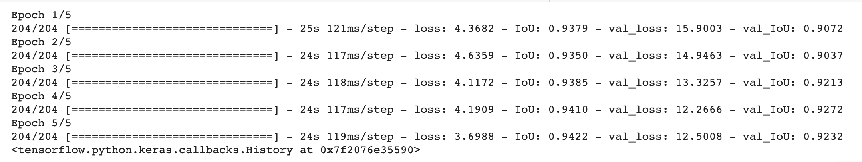

Loss, Accuracy

[13.369744300842285, 0.9216721653938293]

Resnet:

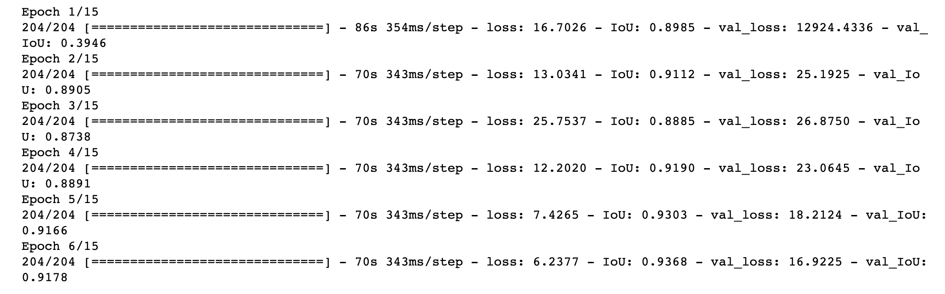

Loss, Accuracy

[17.21445083618164, 0.9168208241462708]

**XceptionNet**

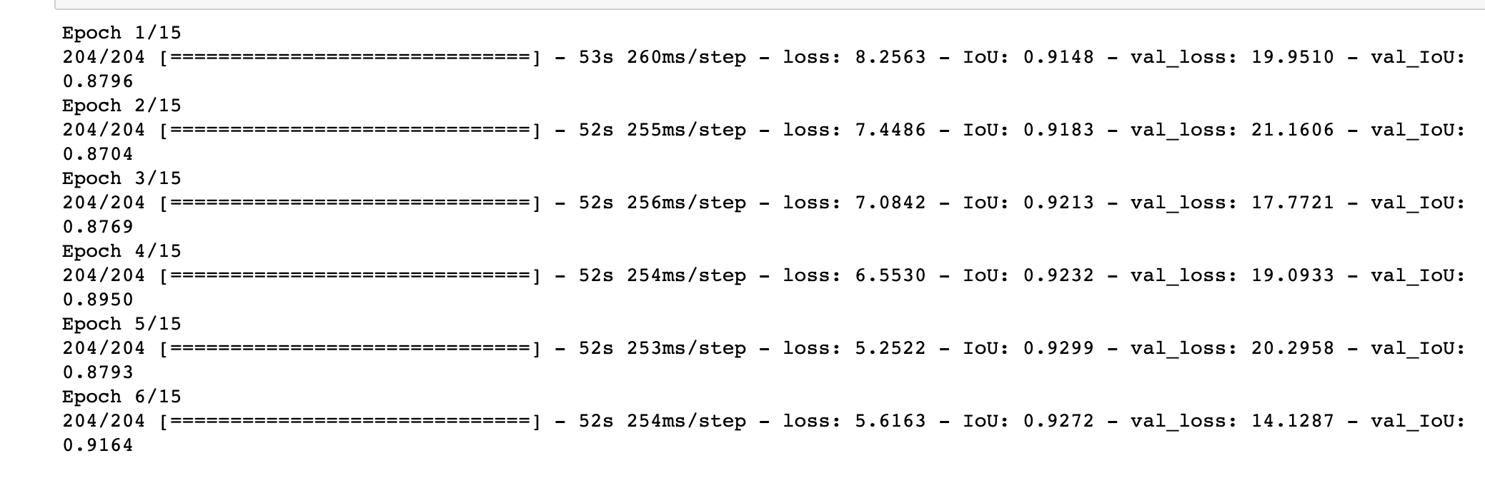

Loss, Accuracy

[14.663599014282227, 0.9170091152191162]

Densenet 121:

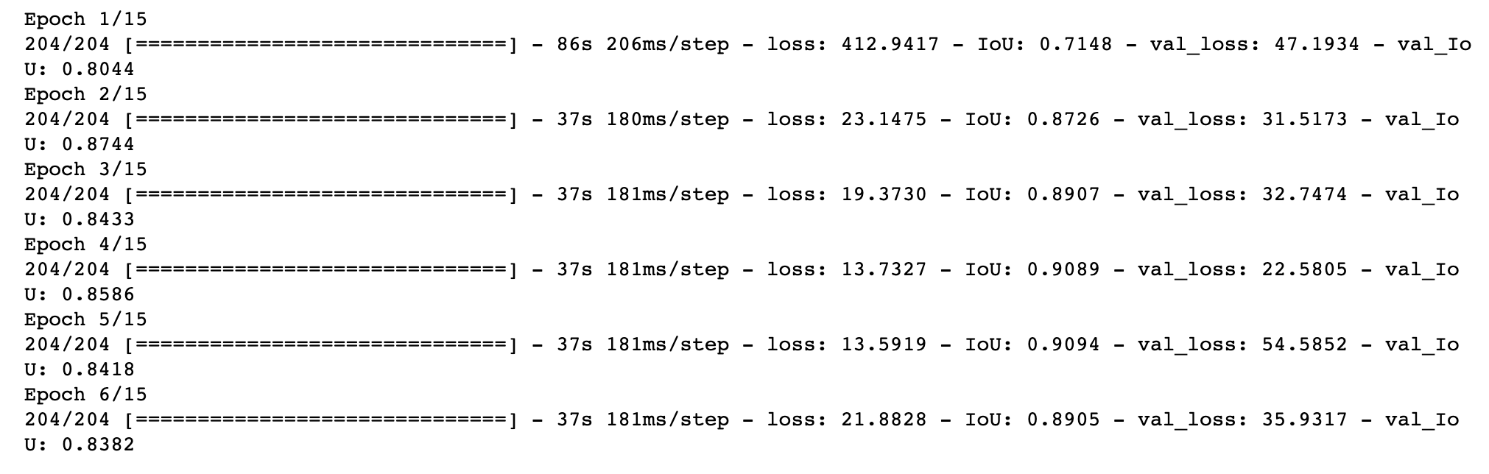

Loss, Accuracy

[38.32698059082031, 0.8373282551765442]

**Thoughts on Classification Accuracy and most confused results:**

The model/s are performing quite well on the test set and also out of the test set as well. We downloaded some of the pictures from internet and tested and the model was able to classify the images.

We can see that the most confusion is between the cars which are of same maker but a minimally changed model or from a different year. These confusions are confusing to human eye as well. Few of the examples are below.

('Audi S5 Coupe 2012', 'Audi A5 Coupe 2012', 17)

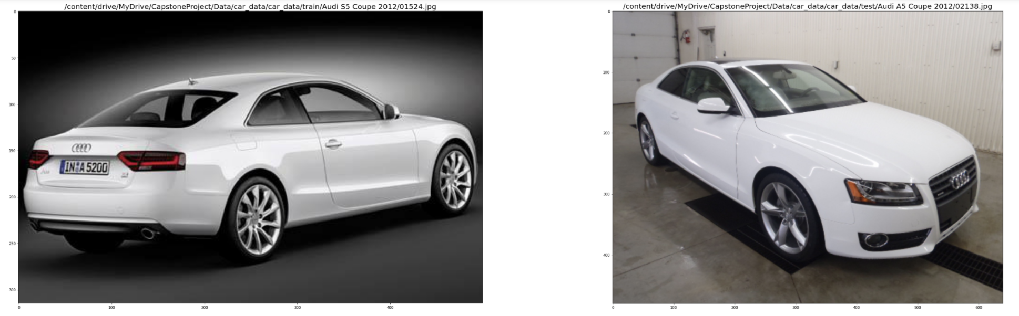

('Audi TTS Coupe 2012', 'Audi TT Hatchback 2011', 16)

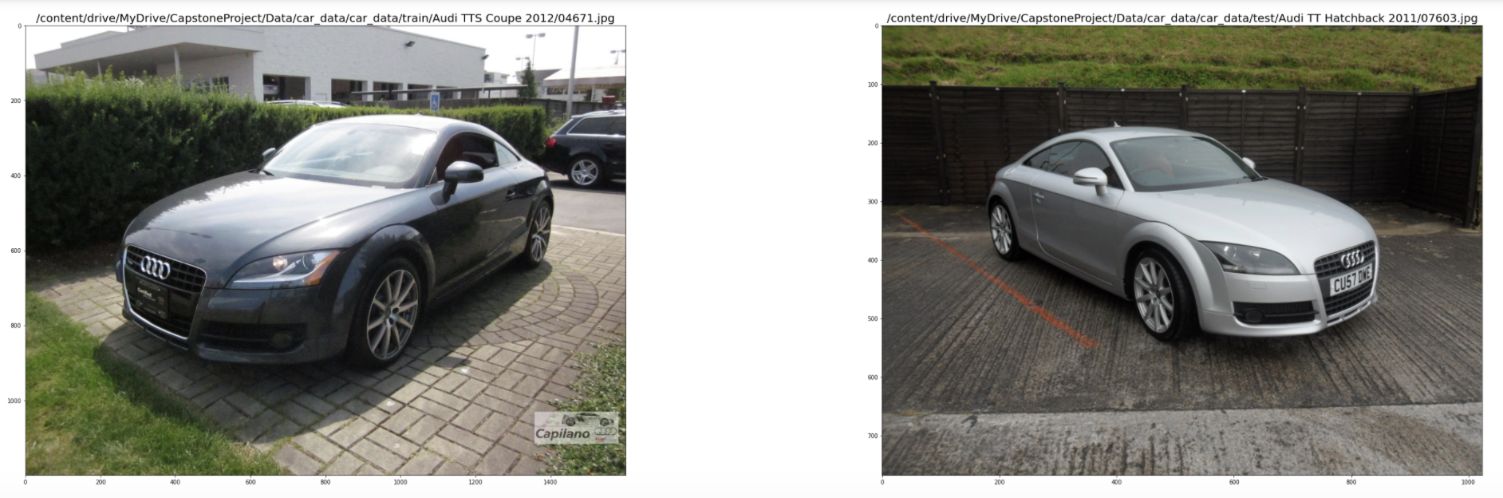

('Dodge Caliber Wagon 2012', 'Dodge Caliber Wagon 2007', 14)

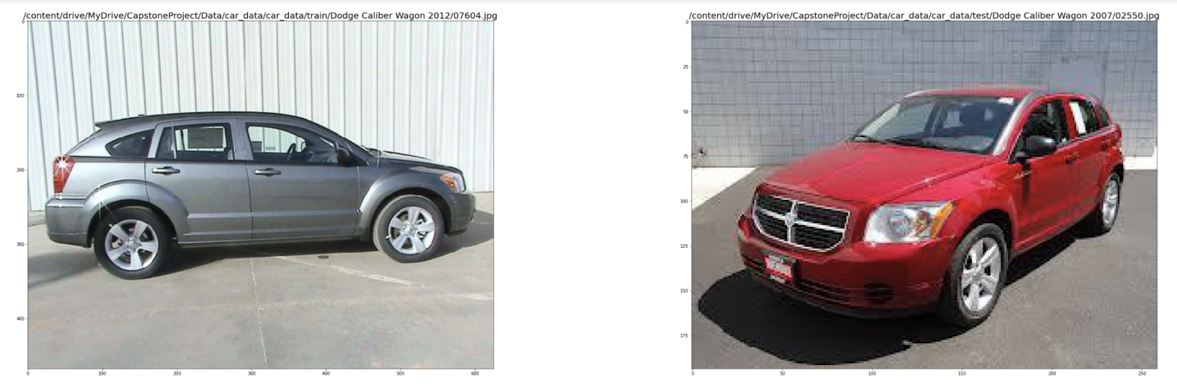

('Audi TT Hatchback 2011', 'Audi TTS Coupe 2012', 12)

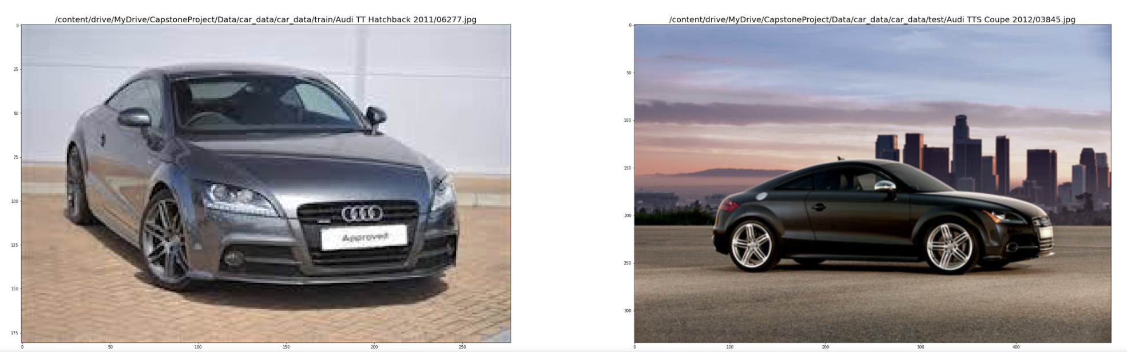

('BMW 6 Series Convertible 2007', 'BMW M6 Convertible 2010', 12)

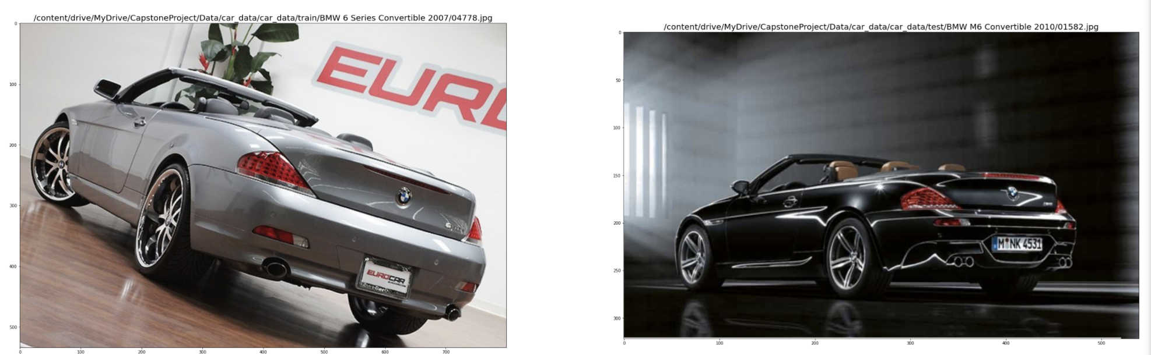

GUI

We have created a GUI based on TKinter libraries. Attaching the screenshot and then going over each of the entries.

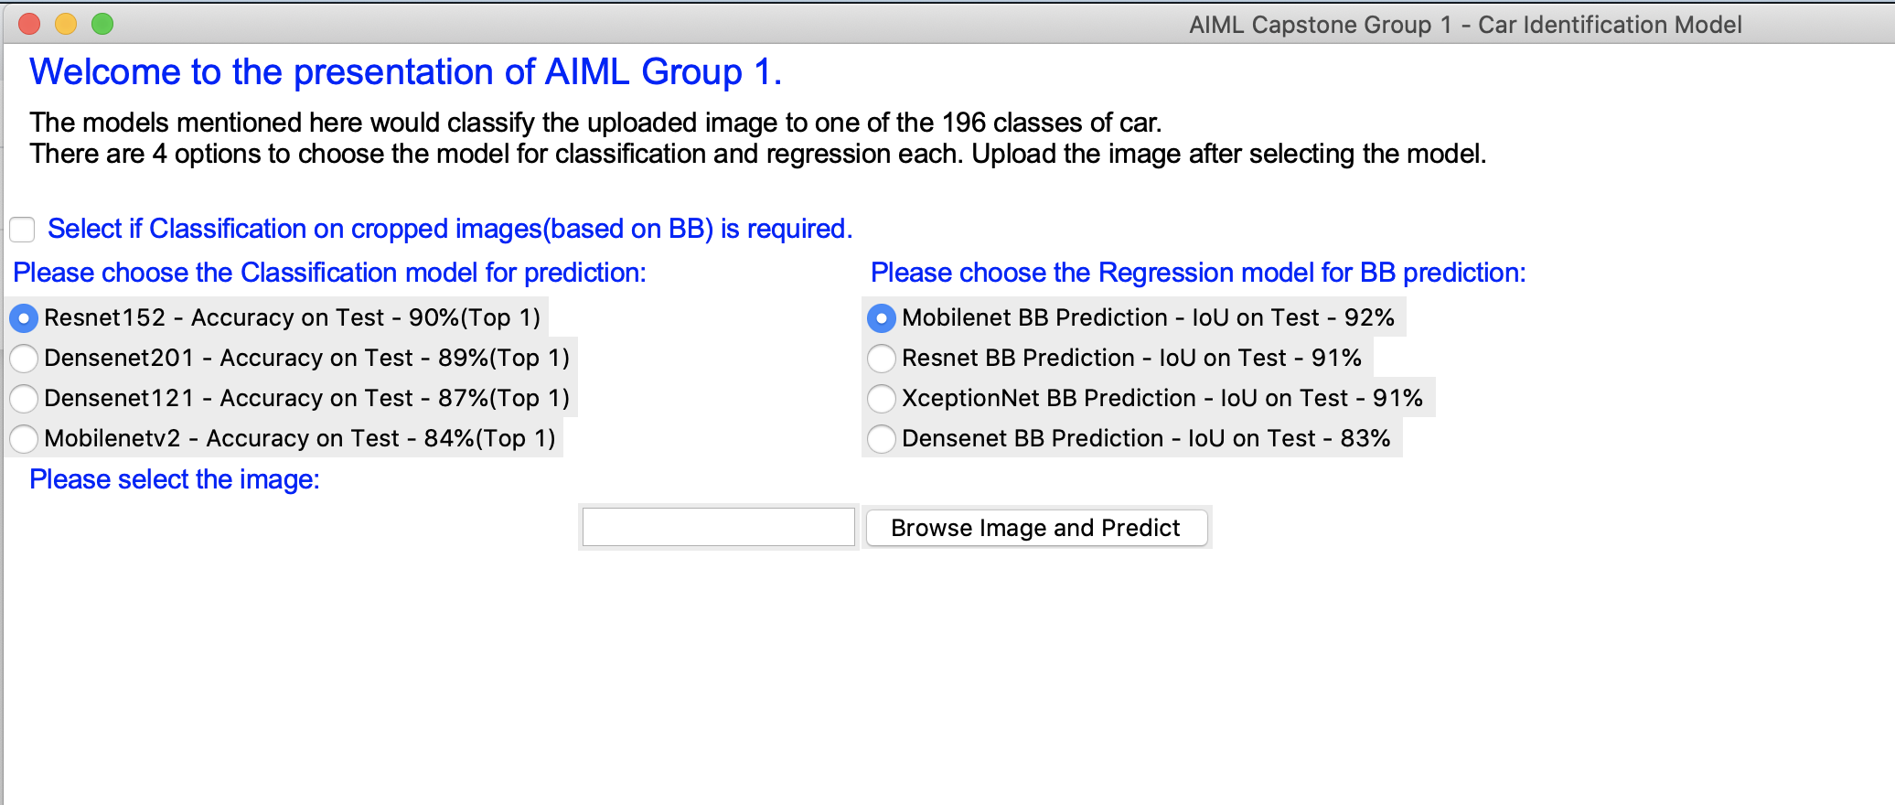

The screen has,

* 1. Check box to let user choose if the cropped image, based on boundary box prediction, should be passed on to classification model. We have seen that if we crop the image and then pass on to the classification model, the confidence level of the result decreases i.e. the model works better on non-cropped images.
  2. Radio button to choose the Classification Model – We have worked on multiple models and gives the option to user choose the model. The Top 1 accuracy for the models are also mentioned.
  3. Radio button to choose the Regression Model – We have worked on multiple models and gives the option to user choose the model. The IoU (Intersection over Union) accuracy for the models are also mentioned.
  4. Browse Image and Predict - This lets choose the user to browse the image file and seek predictions.

After prediction,

The input image has been taken from internet.

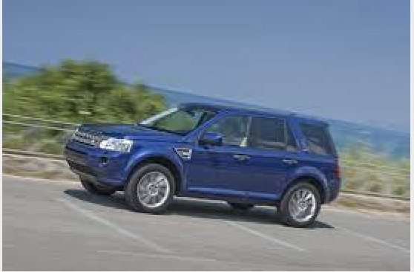

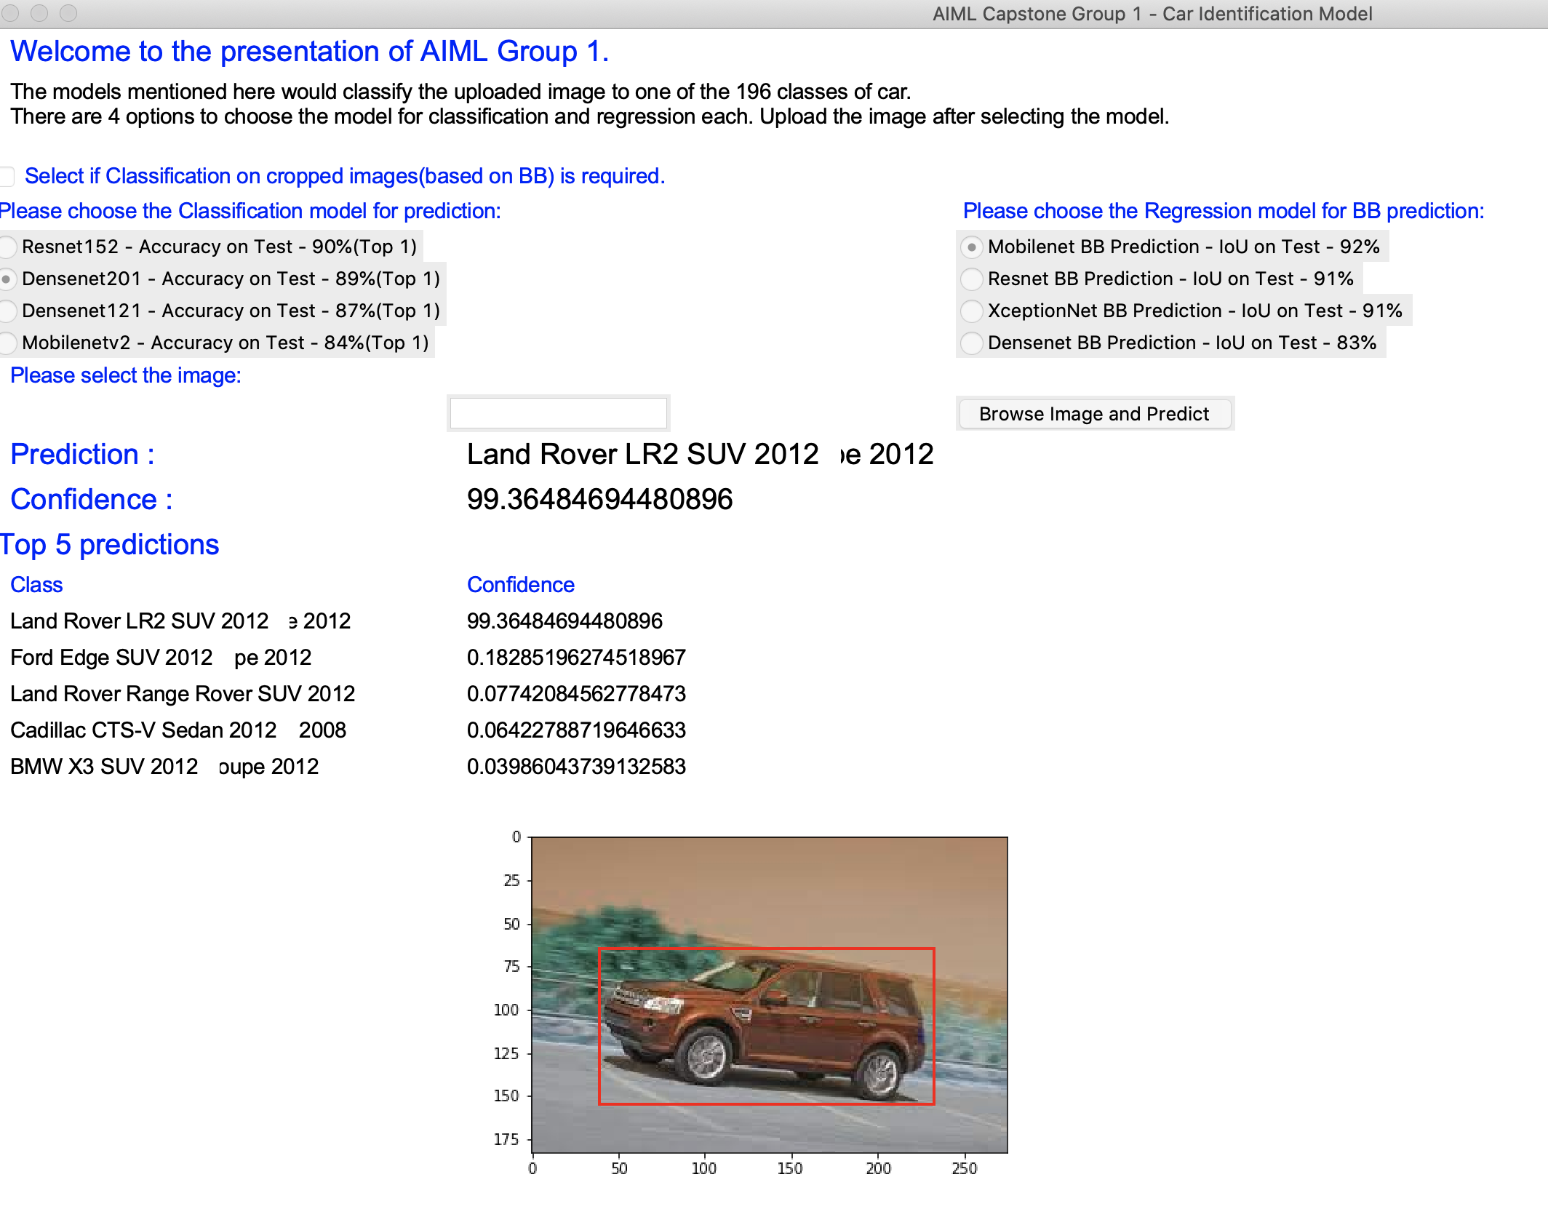

* 1. Prediction – This shows the predicted class.
  2. Confidence – This shows the confidence the model has on this prediction.
  3. Top 5 predictions – This is shown based on top 5 probabilities returned by the model. This is useful in cases to identify what the other car models confuses the car with and with which confidence level.

Examples:

1. Resnet152 model predicting the car wrong but Densenet201 predicting it correctly.

Prediction with Resnet152

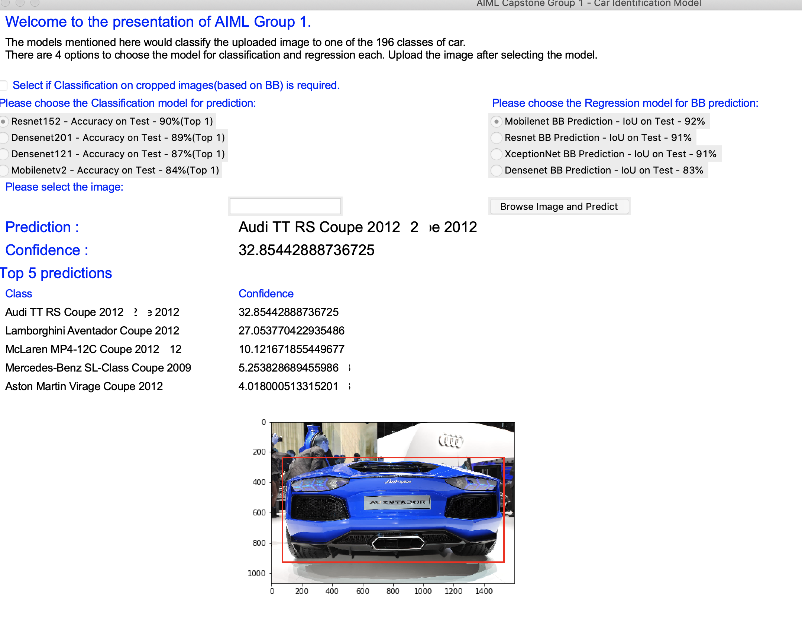

We can see that this is a wrong prediction by the Resnet model. Its interesting to see the confidence level of this prediction, which is just 32%.

The correct one (Top 2nd) is with a confidence percentage of 27%.

Prediction with Densenet201

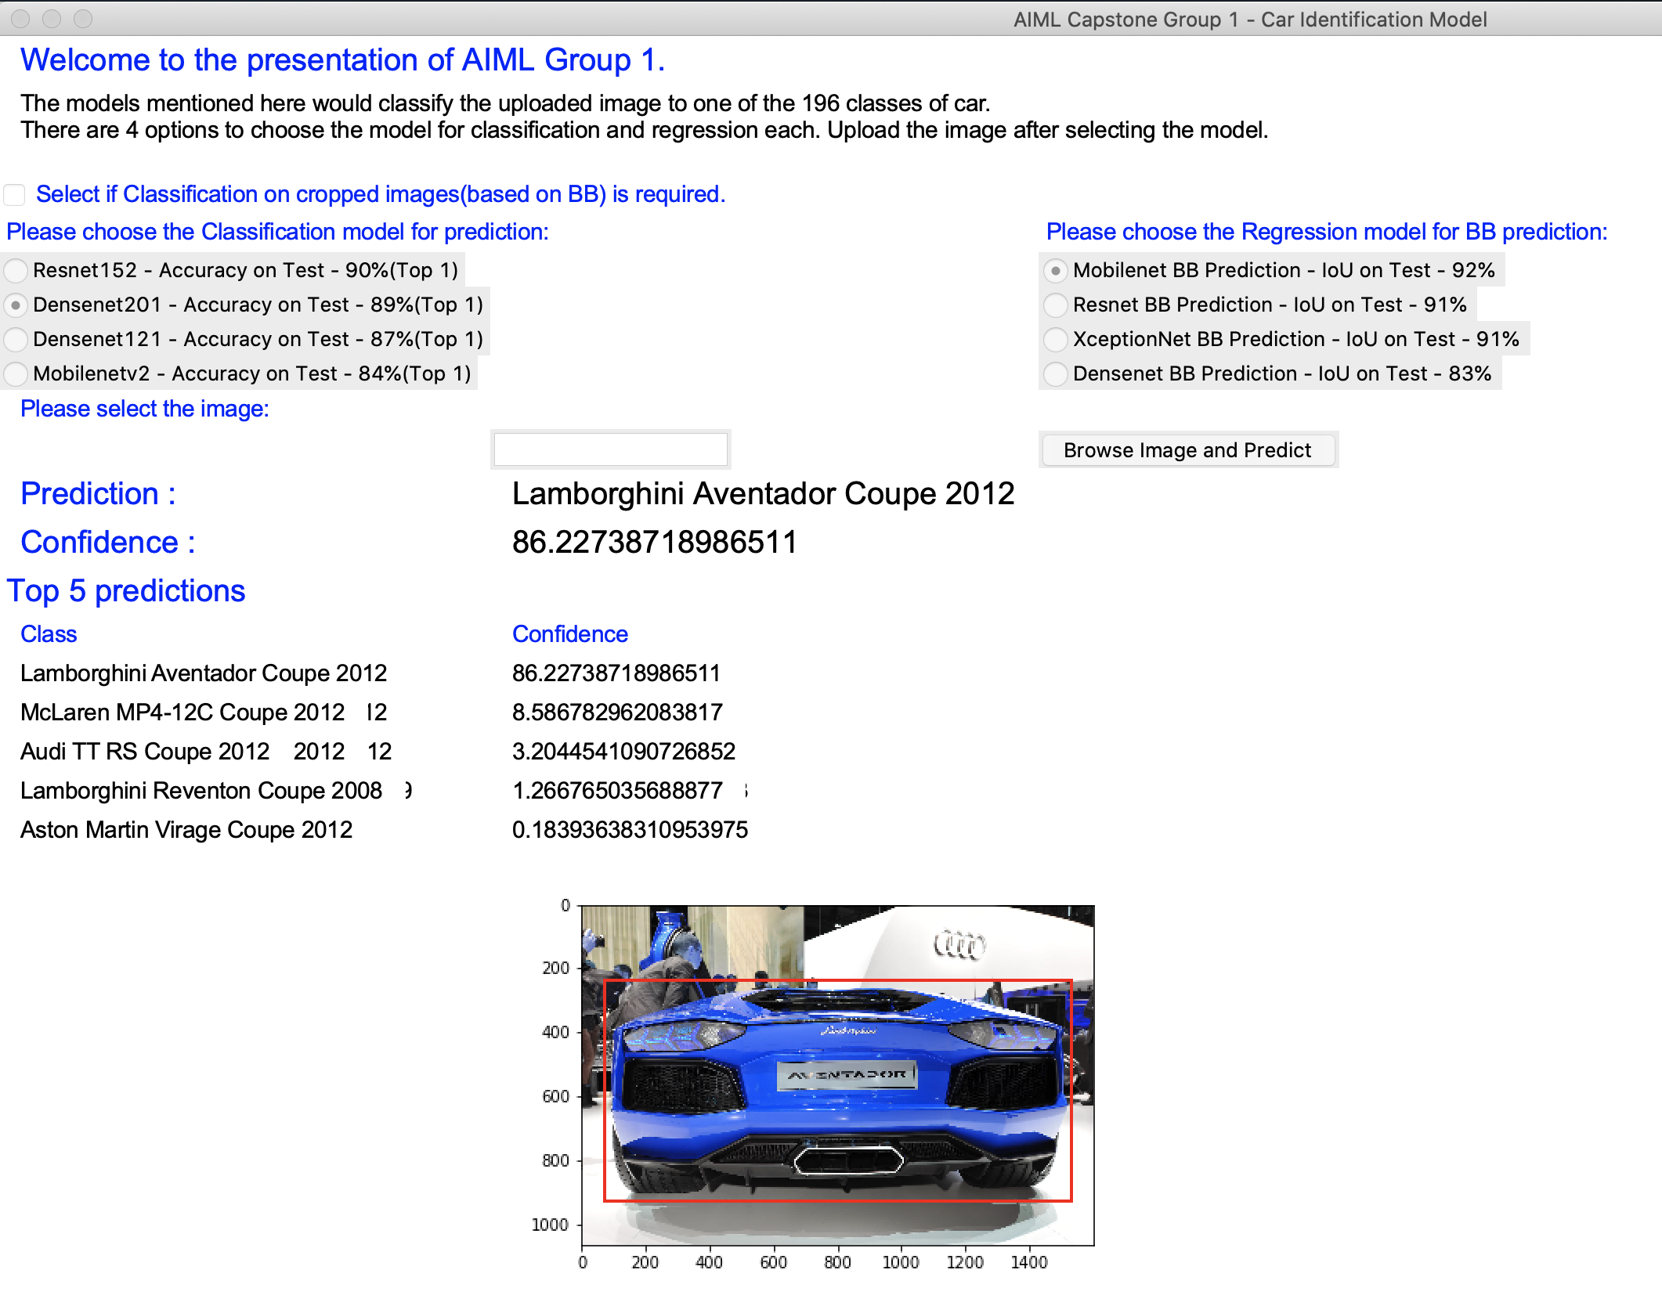

This model predicts the car correctly with a high confidence value of 86%.

1. Checking with option of passing the cropped image to the model.

Input image

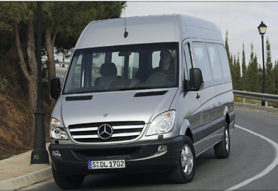

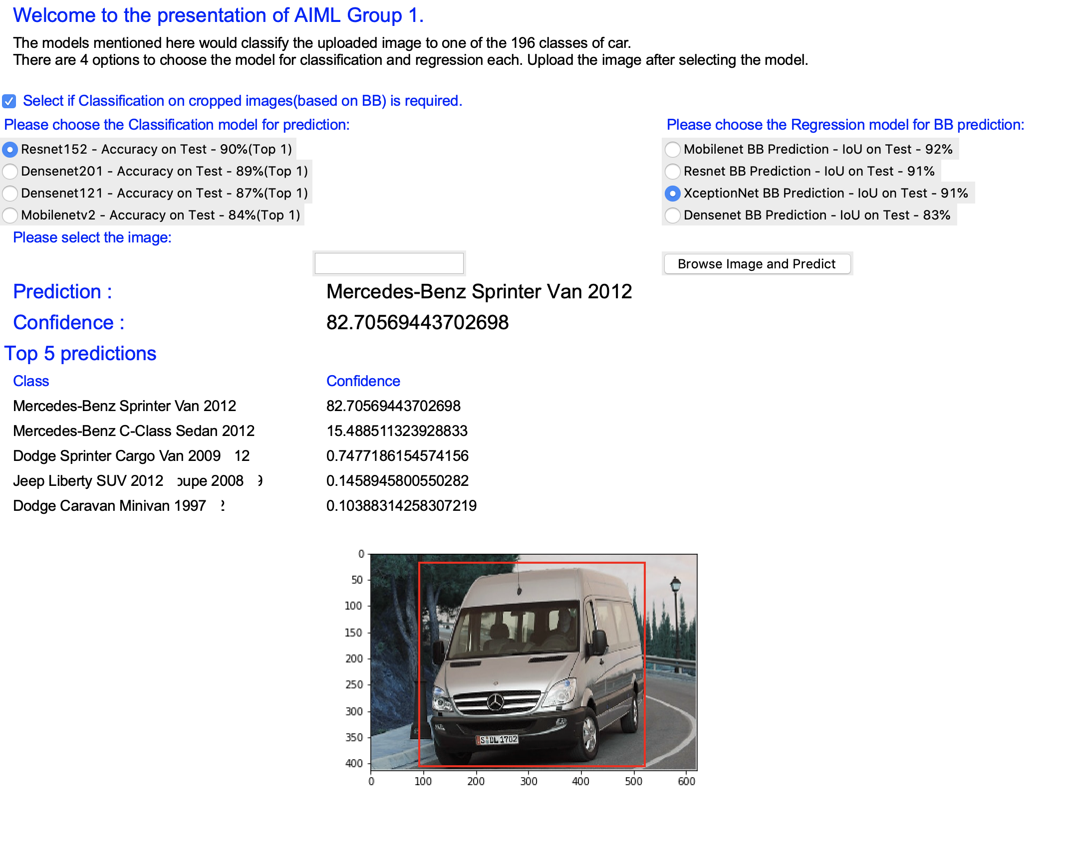

Note: We have selected the classification on cropped image.

Cropped Image passed to the model :

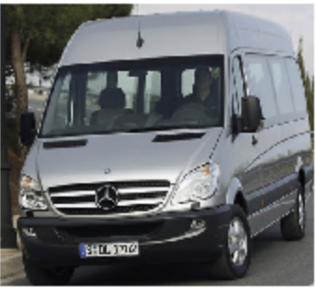

The prediction is correct with 82% confidence.

Now without checking the box for cropped image:

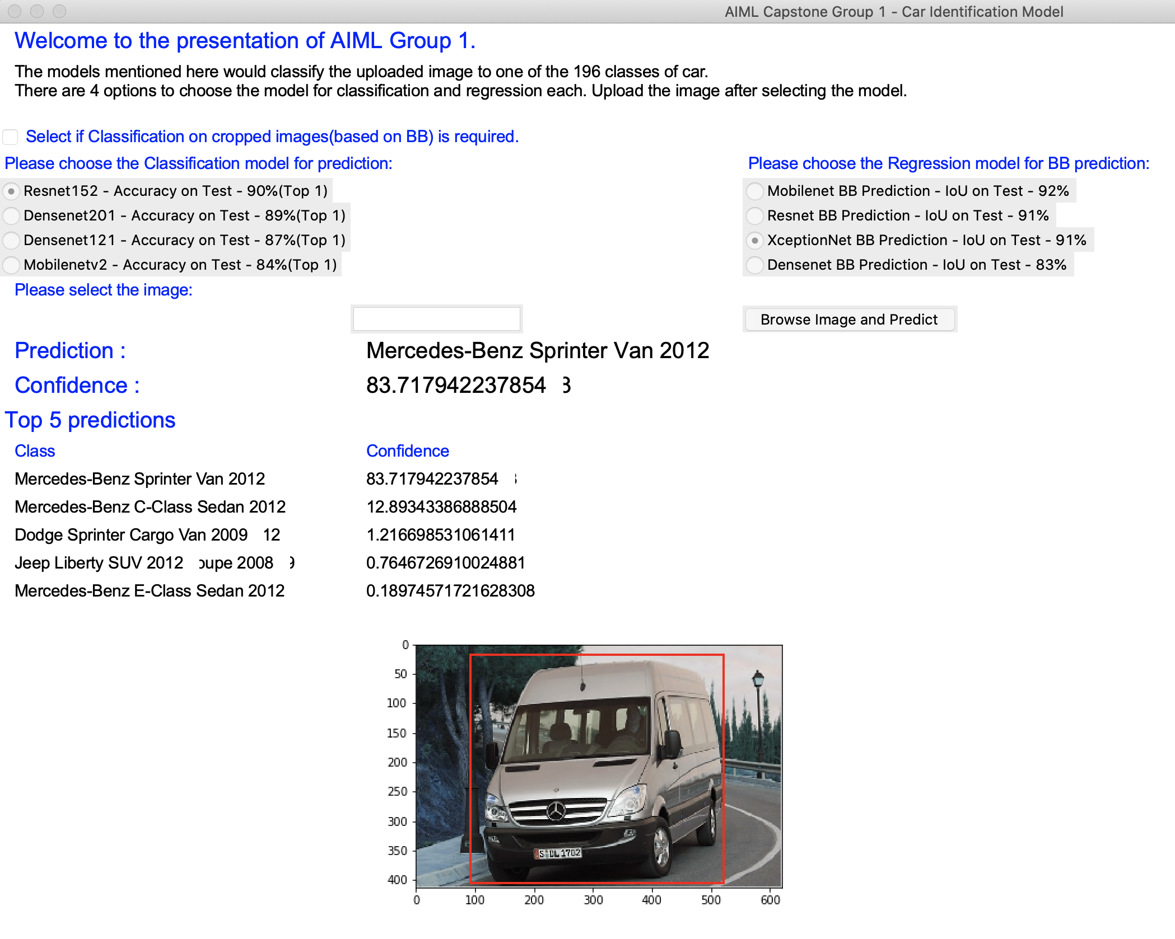

Without cropping the image, the confidence level is 83%. We will see a one more example of this.

Input image:

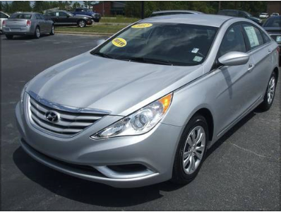

With cropping:

Cropped image sent to model:

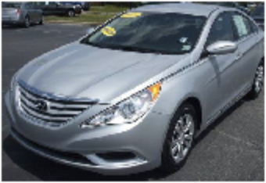

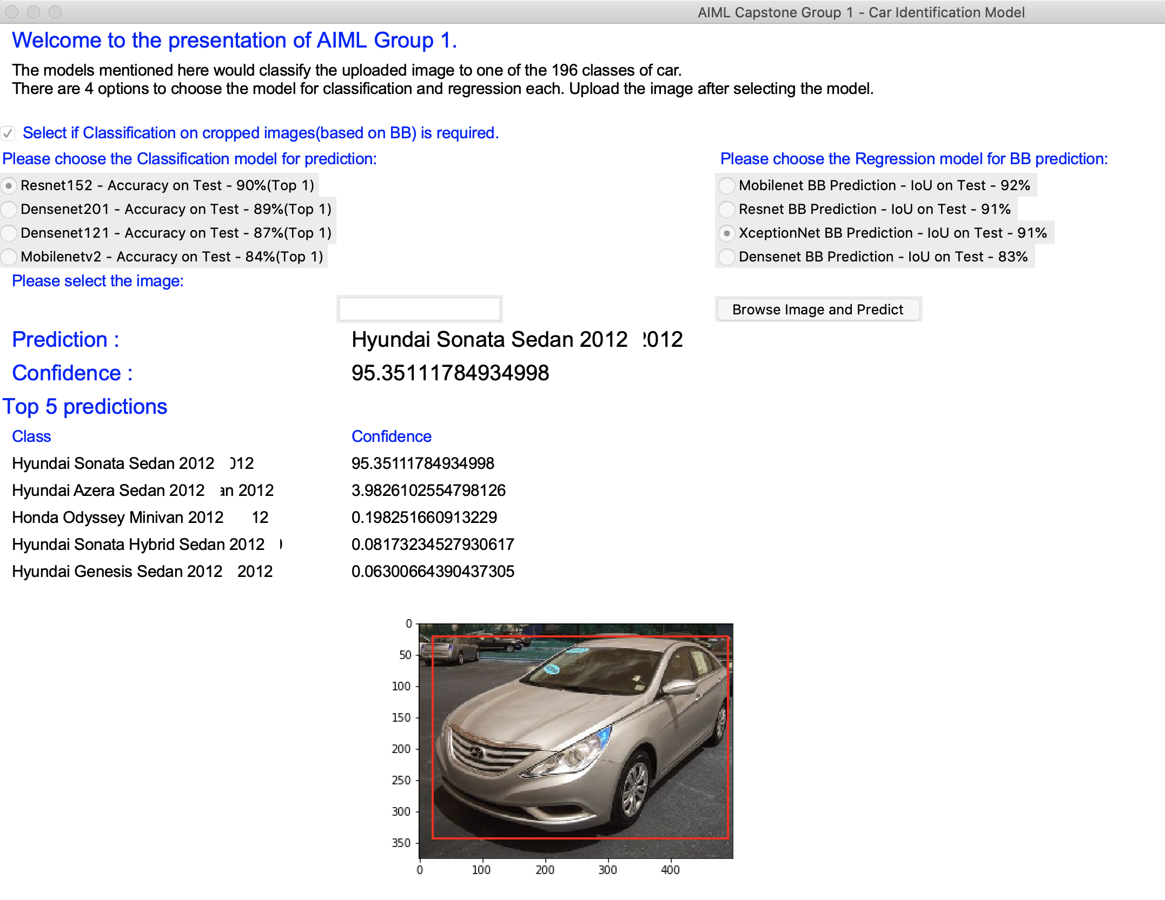

Without Cropping:

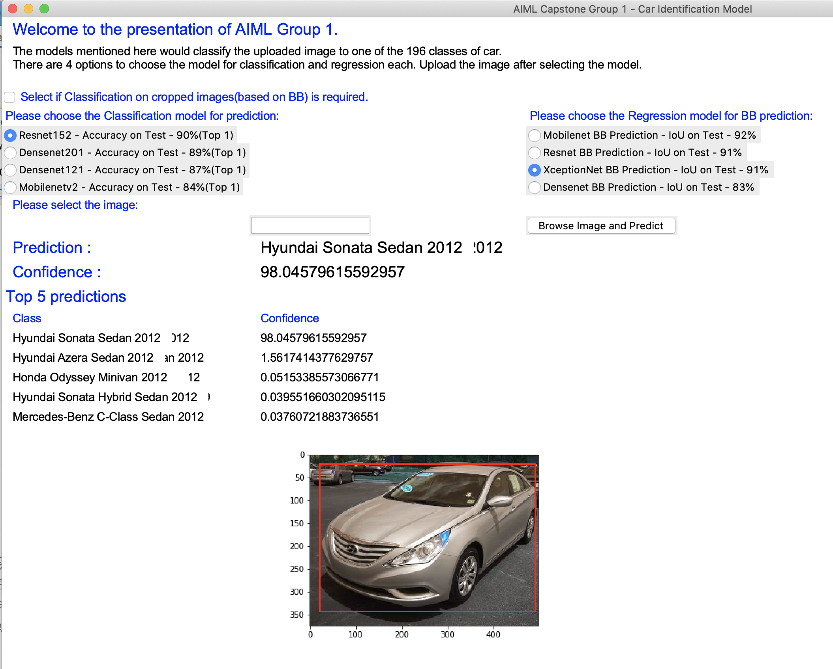

Input Image:

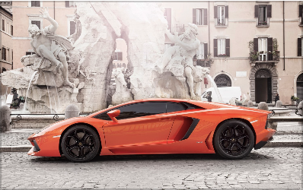

With Cropping:

Cropped image sent to model:

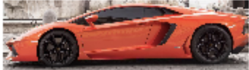

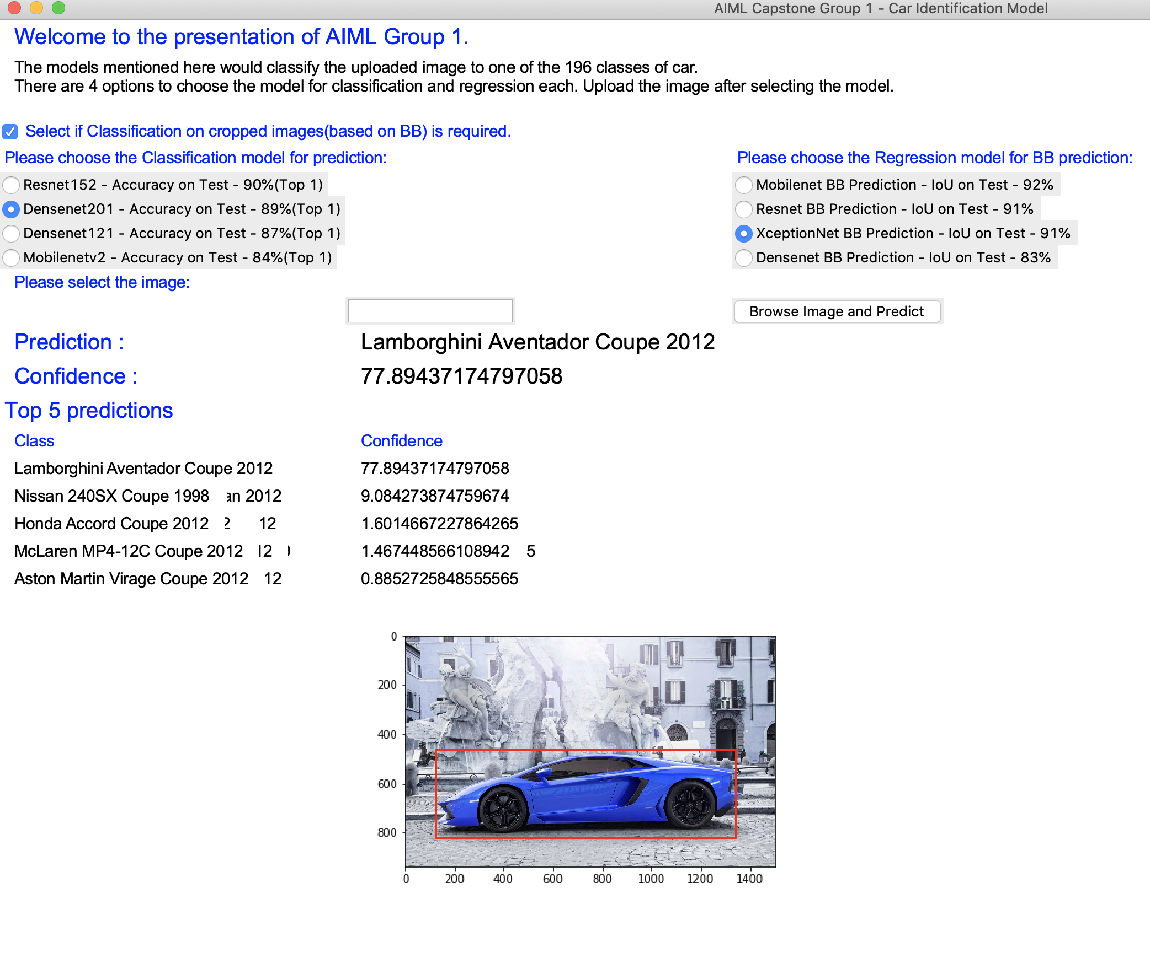

Without Cropping:

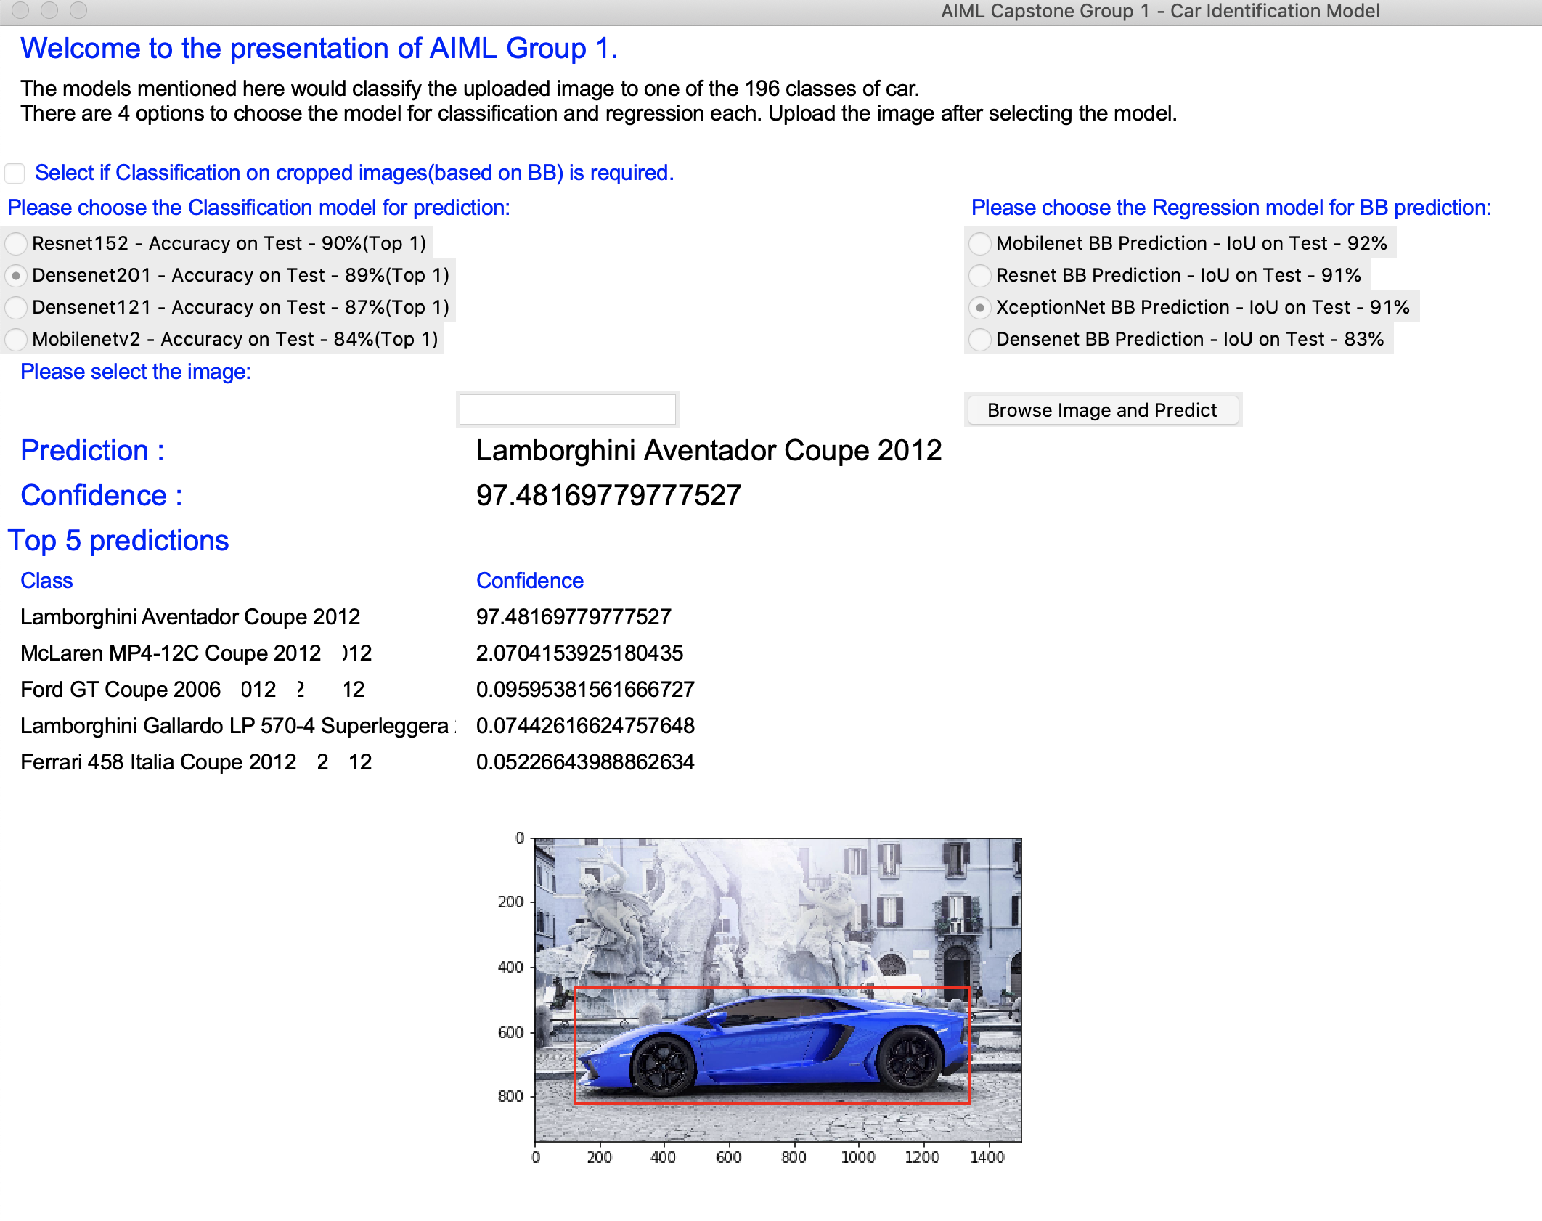

We can see a huge jump in confidence level when the model predicts on without cropped images. Also we can see the other predictions in top 5 are also not same.